Candidate’s Name: Mr/Ms __________________________________________________
sET 2016-B
Identity no: _______________________ Date: ________________ Seat no: ______


Singapore

Design Screening Test

Time Allowed: 1.5 Hours

Instructions to Candidates:

- Do not start until you are told to do so.
- Check that there are seven (7) printed pages in this booklet consisting of:
Section A - Six (6) questions - 60 marks
Section B - Two (2) questions - 40 marks
- Answer all the questions. Questions in Section A carry 10 marks each while Questions in Section B carry 20 marks each.
- All answers are to be written in THIS booklet.
- Write your name, identity and seat number on this cover page.
- This booklet is the property of BCA Academy and must not be taken out of the test centre.

Materials that you need to bring:  - B or 2B pencils & eraser  - Coloured pencils (12 colours will do)  - Scissors and glue stick | Materials that will be provided:  * One piece of coloured paper.

For Official Use: | Test Centre: | Test Date: | Marks  /100:
 | Marker: | Checker: | Marks  /100:
Section A: Free Hand Sketching (60%)

- There are six (6) questions in this part.
- You should spend about 60 minutes in this section.
- Please use 2B pencils for drawing.

  - Sketch the three 3-dimensional (3D) view of a wallet/handbag in the box below.

  - From the given picture, draw and complete the picture using combination of objects -leaves, flowers, grass, people, etc, of your choice. (Use minimum 3 objects)

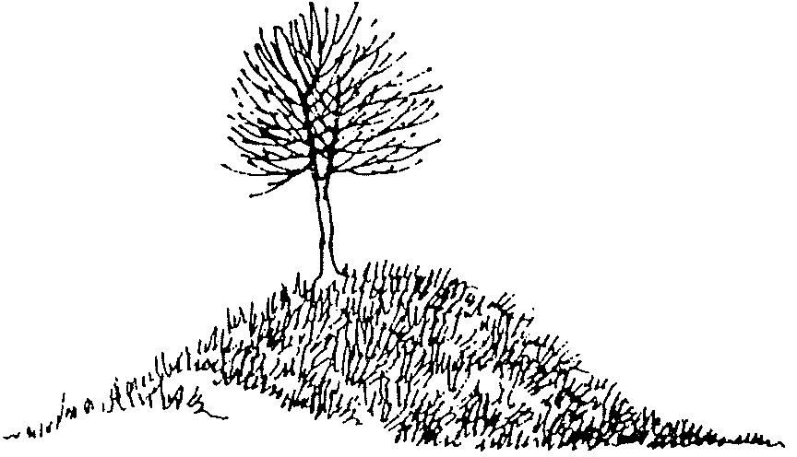

- Draw the enlarged view of the picture shown to fill up the box below. The proportions should be maintained. There is no need to shade. DO NOT USE ANY RULER.

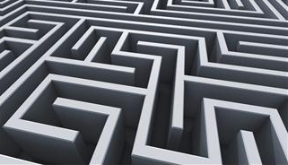

- The darkest square and the lightest square have been shaded for you. You are to use a pencil to gradually shade the remaining three (3) squares from dark to light.

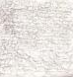
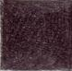

Darkest lightest

- The plan below shows the planes of an object. Sketch out the 3D form if these planes were folded up. Use the guidelines given as the starting point.

Eg:

base
base

6. Sketch the plan (A) and side view (B) of the 3D form shown below.
Eg:
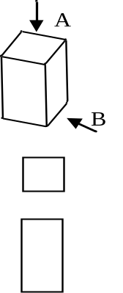
A
A=

B=

B

PLAN (A) VIEW (B)

Section B: Creative Composition (40%)

- There are Two (2) questions in this part.
- You should spend not more than 30 minutes in this section.

7(a). Colour the diagram below with 3 to 5 colours. You may use any technique to do it.

7(b). Using a 2B pencil, draw four (4) different designs from the basic set given below.

8. Do an interesting art work by cutting up the coloured paper provided, into four (4) triangles and six (6) squares. You decide on the size/proportion.

Glue them within the box below. Do NOT overlap any of the shapes. You may draw in some lines to tie up the composition.

Give your artwork a name: _____________________________________________

END OF PAPER

