BCAA e-AST guideline
BCAA will be having the e-AST for both local and international candidates:-
Before the test:
Pls register the candidate by filling the excel below.
IMPORTANT: Pls set the login userID and password for your students, they will be using these info to log into the moodle for taking the eAST.

During the test:
Test date: August 14, 2020 (Friday)
Briefing: 08:55am-09:00am
English: 09:00am-10:30am
Maths/Reasoning: 10:40am-12:10pm
Oral Interview: 12:15pm-13:30pm

Written test: Moodle Account. Visit https://lms.bcaa.edu.sg/
Go to My CoursesAdmission Screening Test to take English, Maths/Reasoning AST
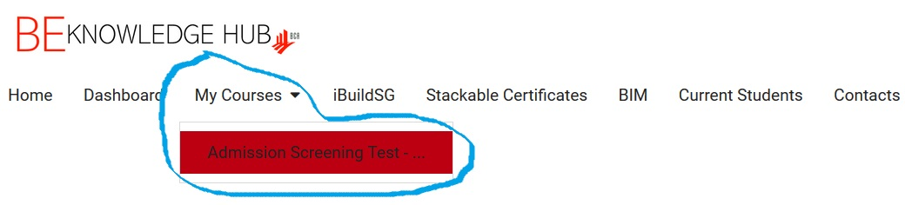
The Briefing and Oral interview is conducted through ZOOM. please download the software in advance. After opening Zoom, click: Join, and type in meeting ID and password, click Join Meeting and wait for the examiner's permission to enter.
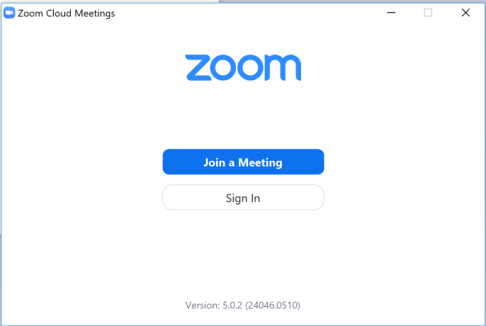
After the test:
The results will be released within two weeks after the AST.

